

**School of Comp. Science**

**Department of Cybernetics**

**GRAPHICS & ANIMATION**

**TOOLS LAB FILE**

**Submitted By Under Guidance of**

**Pranay Gaur Dr. Durgansh Sharma**

**B.Tech CSE-OSSOS Associate Professor**

**500062466 Dept. of Cybernetics**

# 

# Experiment 6

## Aim: Create 3D Hut using Blender 2.8

Step 1:

1. Use the base cube shape and apply texture into it.
2. Use the subdivide modifier on the front face, and the select some area and delete those faces for gate.

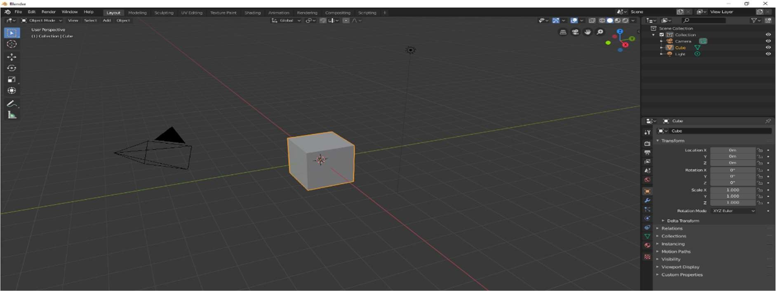

Figure 1: BASE SHAPE

Step 2:

1. Use another 3D cube and press “S+X+0” to turn it into pyramid.
2. Place the pyramid on top of the prepared shape.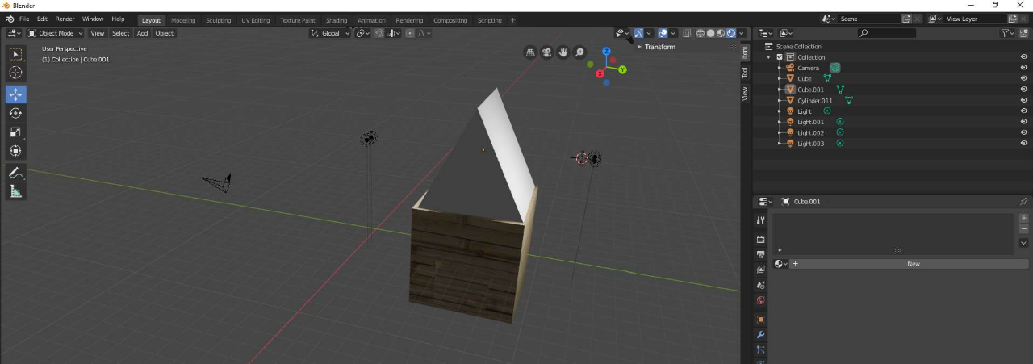

Figure 2: POSITIONING OF ROOF ON HUT BASE

Step 3:

1. Apply base texture on hut’s roof surface.
2. Take a plane, apply a “Red roof clay tile” texture on the plane.
3. Make multiple copies of the tile, and place it with alignment to the roof’s both sides.

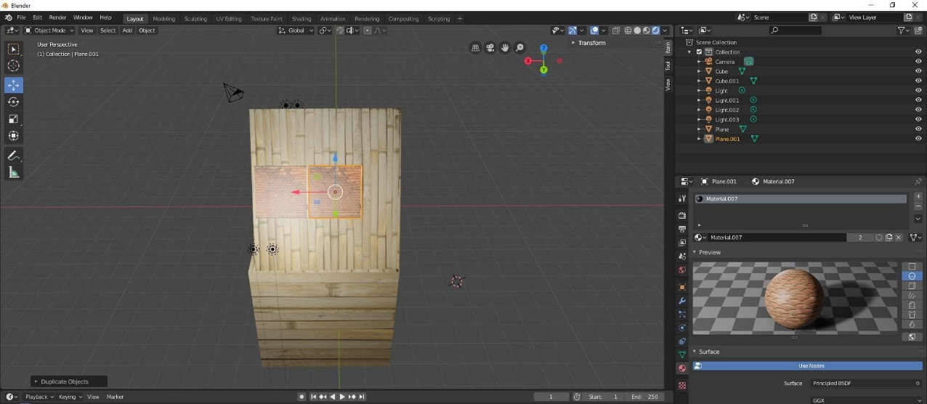

Figure 3: ROOF TILING

Step 4:

1. Take a new plane face, resize it as per gate cut-out size.
2. Apply gate texture on the plane.
3. Align the gate to the gate cut-out.

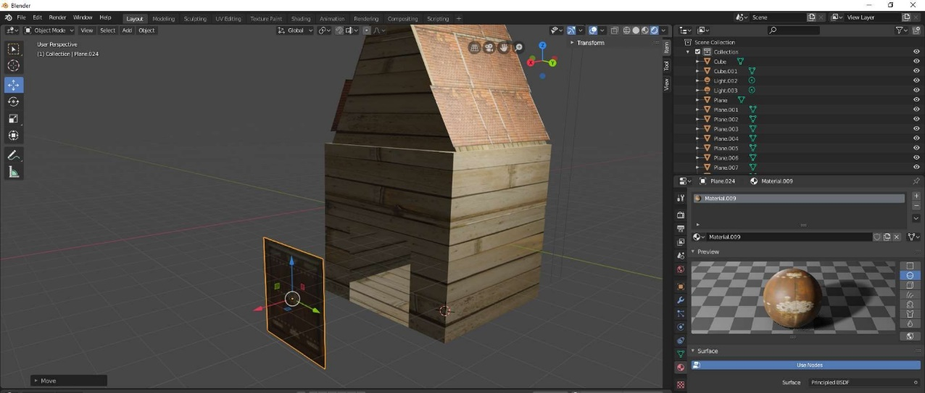

Figure 4: GATE ALIGNMENT

Step 5:

1. Take a new plane, resize it as per the roof size.
2. Apply a window texture on the roof.
3. Align the window plane to its right position.

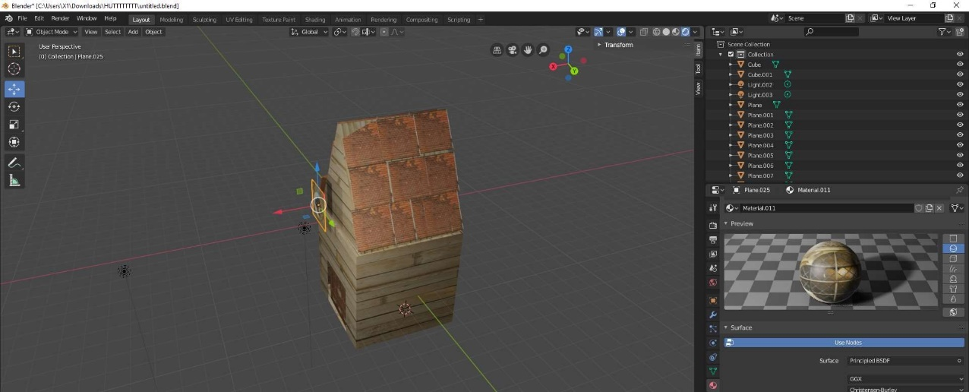

Figure 5: ALIGNING WINDOW ON HUT

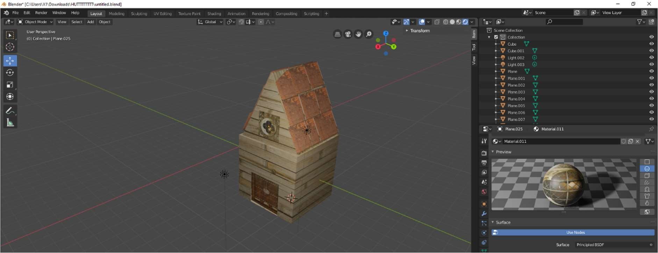

Figure 6: FINAL OUTPUT

**Google Drive Link:** https://drive.google.com/drive/folders/1DJw1N-IBcVs86JXVP998GmWNmW9WGCKs?usp=sharing